**The Lute Music**

**of**

**PHILIP ROSSETER**

**Edited by Robert Spencer**

**and revised by John H. Robinson and Stewart McCoy**

**THE LUTE SOCIETY MUSIC EDITIONS**

Published by The Lute Society 1998/revised 2023

Tel: (+44/0)1483 202159

e-mail: Lutesoc@aol.com

Website: www.lutesoc.co.uk

**The Lute Music of Philip Rosseter**

**Contents**

page

Introduction . . . . . . . . . . . . . . . . . . . . . . . . . . . . . . . . . . . . . . . . . . . . . . . . . . . . . . . . . . . . . . . . . . . . . . . v

Editorial Method . . . . . . . . . . . . . . . . . . . . . . . . . . . . . . . . . . . . . . . . . . . . . . . . . . . . . . . . . . . . . . . . . . . vi

Acknowledgements . . . . . . . . . . . . . . . . . . . . . . . . . . . . . . . . . . . . . . . . . . . . . . . . . . . . . . . . . . . . . . . . . . vi

Sources . . . . . . . . . . . . . . . . . . . . . . . . . . . . . . . . . . . . . . . . . . . . . . . . . . . . . . . . . . . . . . . . . . . . . . . . . . . vii

Illustrations . . . . . . . . . . . . . . . . . . . . . . . . . . . . . . . . . . . . . . . . . . . . . . . . . . . . . . . . . . . . . . . . . . . . . . . . vii

Inventory of Music with Concordances and Notes . . . . . . . . . . . . . . . . . . . . . . . . . . . . . . . . . . . . . . . . ix

Philip Rosseter's Publications and other settings of his music . . . . . . . . . . . . . . . . . . . . . . . . . . . . . . . . xi

**Lute Solos**

1. Prelude . . . . . . . . . . . . . . . . . . . . . . . . . . . . . . . . . . . . . . . . GB-Cfm 689, f. 10r . . . . . . . . . . . . . . . 1

2a. Fantasia . . . . . . . . . . . . . . . . . . . . . . . . . . . . . . . . . . . . . . . . GB-Lbl Eg.2046, ff. 23v-24r . . . . . . 2-4

2b. Fantasia . . . . . . . . . . . . . . . . . . . . . . . . . . . . . . . . . . . . . . . . Mylius 1622, pp. 28-29 . . . . . . . . . . 5-7

3a. Pavan . . . . . . . . . . . . . . . . . . . . . . . . . . . . . . . . . . . . . . . . . . GB-Lbl Eg.2046, ff. 25v-26r . . . . . 8-11

3b. Pavan . . . . . . . . . . . . . . . . . . . . . . . . . . . . . . . . . . . . . . . . . . Mylius 1622, pp. 59-61 . . . . . . . . . 12-15

4. Pavan . . . . . . . . . . . . . . . . . . . . . . . . . . . . . . . . . . . . . . . . . . GB-Cfm 689, f. 21r . . . . . . . . . . . 16-17

5a. Galliard to no. 4 . . . . . . . . . . . . . . . . . . . . . . . . . . . . . . . . . GB-Cfm 689, f. 21v . . . . . . . . . . . . . . 18

5b. Countess of Sussex Galliard 3 . . . . . . . . . . . . . . . . . . . . . . Barley 1596, sig. B3r . . . . . . . . . . . . . 19

6a. Galliard . . . . . . . . . . . . . . . . . . . . . . . . . . . . . . . . . . . . . . . . GB-Cu Dd.9.33, ff. 47v-48r . . . . 20-21

6b. Galliard . . . . . . . . . . . . . . . . . . . . . . . . . . . . . . . . . . . . . . . . GB-Lbl Eg.2046, f. 26r . . . . . . . . . . . 22

7. Countess of Sussex Galliard 1 . . . . . . . . . . . . . . . . . . . . . . Barley 1596, sig. B1r-B1v . . . . . . . . . 23

8. Countess of Sussex Galliard 2 . . . . . . . . . . . . . . . . . . . . . . Barley 1596, sig. B2r-B2v . . . . . . . . . 24

9. Galliard . . . . . . . . . . . . . . . . . . . . . . . . . . . . . . . . . . . . . . . . D-Kl 4˚ 108/I, f. 99r . . . . . . . . . . . . 25

10. La Bergere Galliard . . . . . . . . . . . . . . . . . . . . . . . . . . . . . . . GB-Cu Dd.9.33, ff. 46r-46v . . . . 26-27

11. Almain . . . . . . . . . . . . . . . . . . . . . . . . . . . . . . . . . . . . . . . . . GB-Lam 603, f. 28v . . . . . . . . . . . . . 28

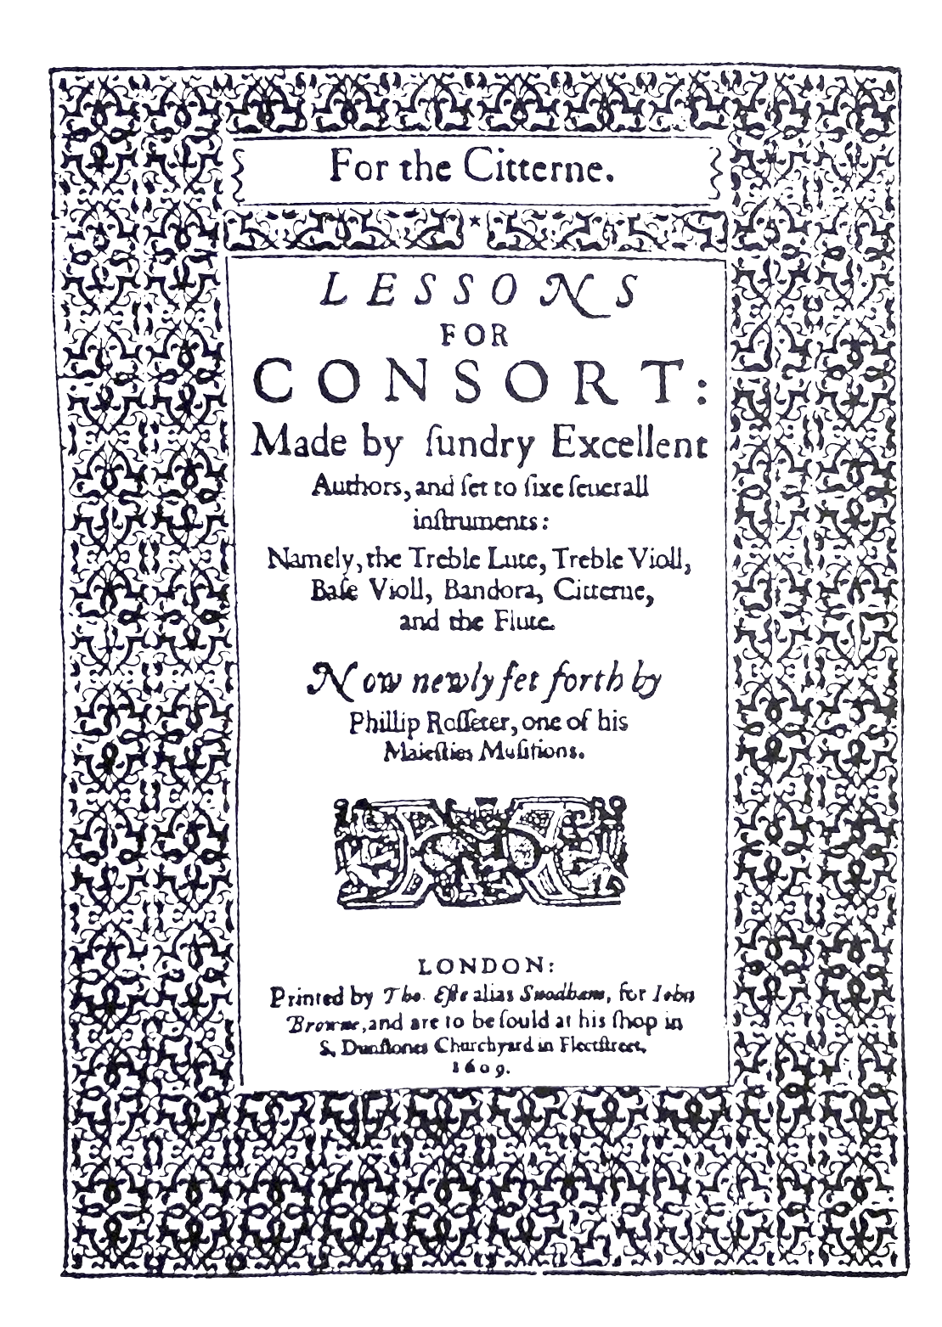

Title page of cittern part of Rosseter’s *Lessons for Consort* (London, 1609). **Introduction**

In a lawsuit of 1601 Philip Rosseter gave his age as 33, indicating that he was born in 1567 or 1568.[1] The lawsuit concerned the printing of Dowland’s *Second Booke of Songs*[2] and Rosseter’s signature to his deposition is here reproduced:

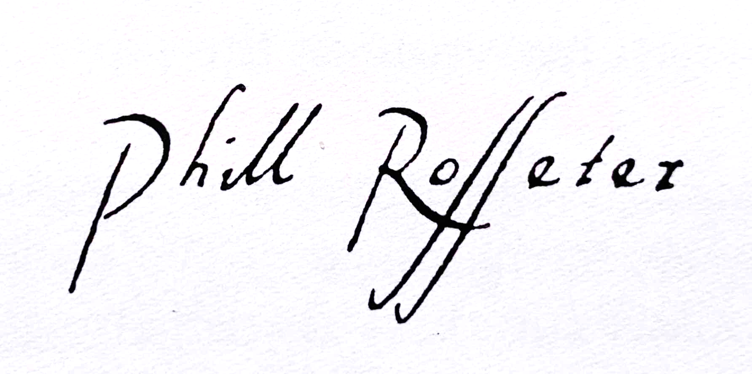

Philip was a member of a family named Rosseter frequently mentioned in Dutch archives of the early seventeenth century.[3] However, it is not known where he was born or how he received his musical training, but we can assume that, as he did not take a degree at university, he was probably apprenticed to a lutenist (as was Daniel Bacheler), or to an important family (as was Robert Johnson). Dedications of his music and books show that in 1596 he was indebted to Bridget Morrison-Radcliffe, Countess of Sussex (1582-1623)[4] who lived at New Hall, Boreham, Essex and Clerkenwell,[5] and in 1609 to Sir William Gascoigne (1569-1642) of Sedbury Hall, Gilling, Yorkshire, when the dedication refers to 'yours favours to myself'.[6] His *Ayres* of 1601 was dedicated to Sir Thomas Monson (1564-1641),[7] but Rosseter clearly addressed Monson as patron of Thomas Campion, whose ayres Rosseter printed together with his own. The name of his son Dudley (born *c.*1601) suggests a connection with Robert Dudley, Earl of Leicester, but as Leicester had died in 1588 it is difficult to see what connection. Possibly it was the Christian name of Philip’s father.

Three galliards ascribed to Rosseter were printed in William Barley’s *A New Booke of Tabliture for the Orpharion* (1596),5 identified only by the initials P. R., (cf. facsimile of sig. B3r reproduced on p. 17 of this edition). They are included in this edition as lute solos 5b, 7 & 8.

In the 1601 lawsuit mentioned above, Rosseter was styled 'musition' living in 'the parish of St Briggettes', that is, St Bride’s; and this was confirmed in the *Booke of Ayres* printed in the same year (see facsimile pages reproduced on pp. xi, xii & xiii of this edition), which were 'to be solde at his house in Fleetstreete neere to the Gray-hound'.6 In the *Ayres* he styled himself 'Lutenist'. Three daughters, Elizabeth, Ursula and Mary, were christened in St Bride’s 1598-1600, and he was still living in Fleet Street in 1604, when he wrote in the *Liber Amicorum* of the German traveller Hans von Bodeck.[8]

At midsummer in 1604 Rosseter was appointed lutenist to King James I at a salary of £20 a year plus £16 2s 6d livery, in the place of Walter Pierce who had been a 'musician for the three lutes' (consort lutenist) since July 1589.[9] Rosseter’s court wages and payments for lute strings are recorded annually from 1606 until 1623, and it is noteworthy that the strings were for a bass lute from 1620 onwards.[10]

In 1609 Rosseter printed his *Lessons for Consort* (see facsimile pages reproduced on pp. ii, vi & 1 of this edition), of which only the flute part survives complete.6 The unique copy of the cittern part lacks nos. 22-25, and only fragments of nos. 5-9 of the lute parts survive. No copy is known of the treble viol, bass viol or bandora part-books.

In February 1613 Rosseter was employed as a lutenist in Chapman’s Maske of the Middle Temple and Lincoln’s Inn, together with John and Robert Dowland, Thomas Ford, Thomas Cutting and Robert Taylor.[11]

From 1609 we hear of Rosseter’s connection with the theatre, particularly his management of the Children of Whitefriars, later renamed Children of the Queen’s Revels.[12] In 1615 he was principal partner in a scheme to build a new theatre at Porter’s Hall, Blackfriars, but on completion two years later city opposition compelled them to pull it down.[13]

In 1620 Rosseter’s friend Thomas Campion died and 'did give all that he had unto Mr Phillip Rosseter, and wished that his estate had bin farr more' amounting to only twenty two pounds.[14] Rosseter himself died on 5th May 1623 and was buried on the 7th at St Dunstan-in-the-West 'out of Fetter Lane',[15] where he was presumably living at the time of his death. Rosseter's place at court was taken by Maurice Webster.

Ten lute solos and one consort lute part are ascribed to Rosseter and are reproduced here. The genres represented are prelude (1), fantasia (1), pavan (2), galliard (6) and almain (1).[16] Seven are known from one source each only and the other four are found in two sources each. When more than one source survives, each version is reproduced separately. Versions of both Fantasia no. 2 and Pavan no. 3 are found in Pickering and Mylius and are identical throughout except for minor differences in figuration and rhythm, some passages more satisfactory in one source or the other. Fantasia no. 2 was considered by Diana Poulton to be a doubtful attribution to John Dowland due to the similarity with his other chromatic fantasias.[17] However, the authors see no reason to doubt the ascription to Rosseter given that the elaborate divisions to nos. 3, 6a and 10, assuming that Rosseter did composed the divisions, show him to be capable of lute composition with the complexity of the Fantasia and a lack of chromaticism in other compositions by him may only reflect the paucity of his surviving music. The sources include copying errors and omissions the more obvious of which have been amended editorially. The two versions of Galliard 5, in Barley and Herbert, are identical apart from a few differences in figuration. The two sources of Galliard no. 6 differ in that one in Dd.9.33 includes divisions and the other in Pickeringe lacking divisions. The strains of the two sources are closely concordant with some differences in figuration. Pickeringe also shows a tendency for the melodic phrasing to be distributed differently across barlines in strains A and C, suggesting that it is a corrupt copy and so has been amended editorially.

**Editorial Method**

All pieces are notated in French tablature in the original sources and editorial changes are listed in the inventory and changes are indicated in grey in the tablature (the tablature software did not permit this for changes in beamed rhythm signs and hatched diapasons. Changes are indicated by the bar number and position of the note in the bar, followed by the fret and course on the lute where the note would be played. For example, 3/1 refers to the first note in the third bar, and c5 indicates the second fret on the fifth course. Barring and beamed rhythm signs have been standardised without comment. Ornament signs and dots under tablature letters indicating right hand fingering have been included when found in the original sources. Nos. 6a and 10 are from Mathew Holmes third lute book, Dd.9.33 in which he adopted a shorthand form of notating rhythm signs. The rhythm signs are mainly beamed and he omitted many rhythm signs and substituted a dot only above the stave to represent dotted rhythms in many places, tacitly expanded editorially here.

**Acknowledgments**

The first version of this edition was prepared by Robert Spencer in 1989, but not published. It was revised for publication in 1998 following his untimely death in 1997 and has now been revised again. The tablature is set using Wayne Cripps’ TAB programme version 4.3.70 on an Apple Macintosh Intel Core i5 running OS 10.14.6 Mojave.

**Sources**

D-Kl 4˚ 108/I Kassel, Landesbibliothek, MS 4˚ Mus.108 I: Princess Elizabeth of Hessen/Victor Montbuisson lute book, *c.*1611. Facsimile edition (Kassell, Barenreiter 2005).

online facsimile: <https://orka.bibliothek.uni-kassel.de/viewer/image/1484138262748/1/>

GB-Cfm 689 Cambridge, Fitzwilliam Museum, Music MS 689: Lord Herbert of Cherbury’s Lute Book, *c.*1616/7-1640. Facsimile edition (Albury, The Lute Society Music Editions 2019).

GB-Cu Dd.9.33 Cambridge, University Library, MS Dd.9.33, copied by Matthew Holmes, *c.*1600-1605.

online facsimile: <https://cudl.lib.cam.ac.uk/view/MS-DD-00009-00033/1>

GB-Lam 603 London, Royal Academy of Music, Robert Spencer Collection: Margaret Boards’s Lute Book, *c.* 1620-1630. Facsimile edition (Leeds and Dublin, Boethius Press 1976).

Online facsimile: <https://lib.ram.ac.uk/cgi-bin/koha/opac-detail.pl?biblionumber=69879>

GB-Lbl Eg.2046 London, British Library, MS Egerton 2046: Jane Pickeringe’s Lute Book, *c.*1616-1650. Facsimile edition (Clarabricken, Boethius Press 1985).

Online facsimile: <https://searcharchives.bl.uk/primo_library/libweb/action/dlDisplay.do?vid=IAMS_VU2&search_scope=default_scope&docId=IAMS032-001982975&fn=permalink>

Barley 1596 William Barley *A new Booke of Tabliture for the Orpharion* (London 1596). Copies in London, British Library, K.1.c.18; Helmingham Hall, Suffolk; Royal College of Music, G12/1-3. Facsimile edition (Stuttgart, Cornetto 2000).

Online facsimile: <https://repository.royalholloway.ac.uk/items/543662bb-90a6-43ff-9f50-849f99e5de3f/1/>

Mylius 1622 Johann Daniel Mylius *Thesaurus Gratiarum* (Frankfurt am Main 1622). Copy in Kraków, Biblioteka Jagielloñska.

**Illustrations**

p. iv Title page of cittern part of Rosseter’s *Lessons for Consort* (London 1609), by permission of the Royal College of Music, London.

p. viii Dedication from Rosseter’s *Lessons for Consort* 1609, by permission of the Royal College of Music.

p. xiii Title page of Rosseter’s *Ayres* 1601, by permission of the British Library.

p. xiv Dedication from Rosseter’s *Ayres* 1601, by permission of the British Library.

p. xv Address to the reader from Rosseter’s *Ayres* 1601, by permission of the British Library.

p. 1 Address to the reader from Rosseter’s *Lessons for Consort* 1609, by permission of Royal College of Music.

p. 17 Facsimile of no. 5b from sig. B3r of Barley’s *A new Booke of Tabliture for the Orpharion* 1596, by permission of the British Library.

p. 25 Facsimile of no. 9 from Princess Elizabeth of Hessen's lute book (D-Kl 4˚ 108/I, f. 99r).

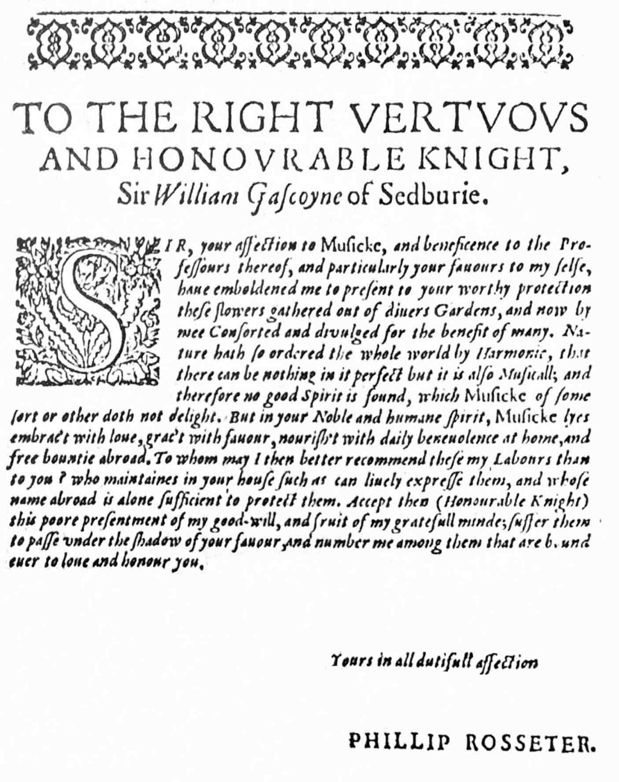

Dedication from Rosseter’s *Lessons for Consort* 1609.

**Inventory of Music with Concordances and Notes**

**1. Prelude**

GB-Cfm 689, f. 10r ii *Prelude P: Rosseter*

Thirteen bars in G minor with 7th course tuned to F, 8th to D and 9th to C.

8-9 - bar line absent

**2. Fantasia**

**a.** GB-Lbl Eg.2046, ff. 23v-24r *A Fantasia*

In G minor with 7th course tuned to D

1-2, 3-4, 68-69 - bar lines absent

23/3 - c4 absent

65/4 - d1 instead of d2

78/before 5 - c2e3e4c6 crossed out

129/9 - c1 instead of b1

131/13 - e4 instead of e3

133/5-6 - bar line added

**b.** Mylius 1622, pp. 28-29 *Grammatica Rosideri Angli generosi*

Title translates as ‘chromatic piece by the English Gentleman Rosseter’

In G minor with 7th course tuned to F and 8th to D

10/2-3 - c1 & e3 vertically instead of horizontally aligned

13/5 - b3 absent

16/5 - e5 absent

19/1 - a2 instead of b2

20/1-2 - quavers instead of crotchets

20/1 - a8 instead of b7

20/3 - a8 instead of a7

20/5 - a9 instead of c8

20-21 - bar line displaced a note to the right

21/6 - a6 instead of a8

21/6-7 - crotchets instead of dotted quaver semiquaver

22/6 - d3 instead of e4

23/9 - a2 instead of a3

25/8 - c3 instead of c4

27/1 - e2 instead of a2

28/7 - a8 instead of a7

30/2 - d2 instead of f2

34/1 - a2 instead of b2

36/7 - e2 instead of d2

37/7 - b3c4 instead of c3b4

38/3-4 - a2-b2 instead of a3-b3

40/6 - c5 instead of c4

44/10 - d3 instead of d2

45/6 - b8 instead of b7

47 - 6 minim bar retained

52/2 - c5 instead of c4

54/11-12 - bar line added

55/<1, 68/<1 - time signatures absent

65/6 - f5 instead of f4

65-66 - bar line absent

66/6 - a5 instead of a4

69/12 - c1 absent

73/3-4 - e5-a4 absent

74/15-16 - d6-a5 instead of c6-d6

76/1 - e4 absent

77/7-8 - semiquavers instead of quavers

80/5 - a6 below previous f1 instead

85 - dotted quaver semiquaver 6 quavers instead of dotted crotchet quaver 6 crotchets

85/2 - a3 instead of a4

85/3 - c6 instead of e6

86/1 - c5 absent

89/6 - a5 absent

**3. Pavan**

**a.** GB-Lbl Eg.2046, ff. 25v-26r *A Pavin by Rossesters*

In G minor with 7th course tuned to D

Three strains of 20, 19 and 19 bars with divisions

Length of bars doubled in the first statement of each strain but not in the divisions, standardised editorially

15/2 - f1 instead of h1

15/4 - a3c4 instead of a4c5

22/1 - d5 instead of d6

26/11 - d1 instead of d3

27/7 - a5 instead of a4

34/6 - l2 instead of i2

36/1 - a5 absent

36/13 - a3 absent

38/1-8 - absent, reconstructed editorially

38-39, 39-40 - bar line displaced 8 events to the right

40/9 - semibreve instead of minim

40-41 - single instead of double bar line

51/4 - a5 absent

54/1 - h2 absent

54/3 - d2 instead of b2

55-56 - bar line absent

57/6 - f1 instead of a1

69/1-8 - quavers instead of semiquavers

69/10 - f2 instead of f1

70/2 - a5 instead of a4

74/1 - a3 absent

88/3 - g4 added

89/1 - c2d3a5 instead of d2d3a4

91/1 - f1 & a5 vertically instead of horizontally aligned

91-92 - bar line displaced a note to the right

93/1 - a5 absent

112/7 - c4 instead of c5

115/7-21 - quaver 14 semiquavers instead of semiquaver 14 demisemiquavers

115-116 - bar line displaced 8 notes to the left

**b.** Mylius 1622, pp. 59-61 *Pauana Anglica*

In G minor with 7th course tuned to F, 8th to D and 9th to C

Three strains of 10, 9 and 18 bars with divisions (10 bars in division to third strain)

6/5 - i1 absent

9/1 - b3c4 instead of b4c5

10/3 - c3 instead of c4

13/17-27 - dotted crotchet 10 semiquavers instead of

dotted quaver 10 demisemiquavers

13-14 - bar line displaced 8 events to the right

16/23, 17/7, 17/21, 18/7, 18/21 - semiquaver

displaced a note left

17/11 - d6 instead of d5

18/28 - c1 absent

19/1 - a8 instead of a6

20/17-20 - absent, added editorialy from 3a

22/4 - a8 instead of a9

23-24, 28-29 - bar lines absent

27/8 - c4 instead of e4

28/6-12 - absent, added editorialy from 3a

32/28 - d2 absent

33/between 4-5 - c3 added

33/11 - d1 absent

33/29-32 - semiquavers instead of demisemiquavers

34/4 - d1 instead of f1

34/17-24 - demisemiquavers instead of semiquavers

35/7-8 - quavers absent

35-36, 36-37 - bar lines displaced 14 events to the left

36/1 - f4 instead of f5

36/22 - b2 instead of b3

38/1 - dotted quaver instead of dotted crotchet

38/10-11- c3-e3 absent

38-39 - single instead of double bar line

40/2 to 41/1 - absent, added editorialy from 3a

42/3 - i3 absent

45-46 - bar line displaced 3 events to the right

46/8 - a2 instead of a1

46-47 - bar line displaced 9 events to the right

49/10 - a8 instead of a6

50/9-12 - 4 quavers instead of quaver 2 semiquavers crotchet

51/12 - quaver instead of crotchet

52/27 - f3 instead of g3

54/13 - f3 instead of i3

54/19 - semiquaver instead of dotted quaver

54/23-24 - quavers instead of semiquavers

55/1 - a4 instead of a5

56/between 9-10 - c1-e1 added

56/15-16 - bar line added

56/20-34 - quaver 14 semiquavers instead of semiquaver 14 demisemiquavers

57/1 - a5 instead of a6

**4. Pavan**

GB-Cfm 689, f. 21r *Pauana Ph: Rosseter*

In F minor with 7th course tuned to F, 8th to E flat and 9th to C. Three strains of 24, 19 and 22 bars without divisions

7-8, 15-16, 22-23, 30-31 - bar lines absent

23/2 - quaver absent

33-34, 38-39, 46-47, 54-55 - bar lines absent

60/4 - a2 instead of a1

**5. Countess of Sussex Galliard 3 (to pavan 4)**

**a.** GB-Cfm 689, f. 21v *Gagliarda della Pauana*

In F minor with 7th course tuned to F

Three strains of 8 bars without divisions

6-7, 12-13, 18-19 - bar lines absent

**b.** Barley 1596, sig. B3r: *Another galliard of the Countesse of Sussex. -- P.R.* (Philip Rosseter) for orpharion

In F minor with 7th course tuned to F

Three strains of 8 bars without divisions

6-7, 13-14, 19-20 - bar lines absent

11/4-5 - g2 vertically instead of horizontally aligned with f4d5

17/3-4 - quavers instead of crotchets

18/2 - right hand fingering dot below following a1 instead of f1

22/4-5 - e3 vertically instead of horizontally aligned with a4

24/2 - a6 instead of a7

**6. Galliard**

**a.** GB-Cu Dd.9.33, ff. 47v-48r untitled

In G minor with 7th course tuned to D

Three strains of 8 bars each with divisions

5/1-2, 5/3-4, 5/5-6, 6/5-6 - dotted crotchets quavers

instead of dotted quavers semiquavers

7-8 - bar line displaced a minim to the right

10/5 - scribe altered h4 to f4

11/7 - scribe altered f1 to h1

11/14 - d1 instead of f1

12/1 - minim present but a2a46 absent

9-10, 12-13, 21-22, 27-28, 31-32 - bar lines absent

15/12-13 - bar line added

32/13-21 - 2 semiquavers 6 demisemiquavers semiquaver

instead of 8 demisemiquavers minim

32/17 - c3 instead of f3

37/2 - a1 instead of d1

40/1 - minim absent

43/8-10 - 2 semiquavers quaver instead of semiquaver quaver semiquaver (to match 43/15-17)

48/6 - m1 instead of n1 (probably notated correctly for a lute lacking an 11th fret glued to the soundboard)

48/10 - quaver instead of dotted quaver

**b.** GB-Lbl Eg.2046, f. 26r *A galyerd by Rossesters*

In G minor for 6-course lute

Three strains of 8 bars without divisions

4/3-6 - quavers instead of crotchets

4-5, 5-6 - bar lines displaced a minim to the right

6/5-7 - 2 crotchets minim instead of 2 quavers crotchet

8-9, 16-17 - '2' above double bar lines at the end of A and B (but not C) strains indicating repeat of previous section

17/1 - a3 instead of a4

18/1 - semibreve instead of dotted semibreve

18-19, 19-20, 22-23, 23-24 - bar lines absent

19/2-3, 23/2-3 - bar lines added

20/1 - minim instead of dotted semibreve

22/1-4 - dotted crotchet quaver twice instead of minim crotchet twice

**7. Countess of Sussex** **Galliard 1**

Barley 1596, sig. B1r-B1v *THE Countesse of Sussex Galliard. -- P:R.* (Philip Rosseter) for orpharion

In C minor with 7th course tuned to F

Three strains of 8 bars without divisions

6/4 - a5 absent

6/5 - a5 instead of a4

7/2 - f7 instead of a7

11/4 - e2 instead of b2

12/3 - c7 added

12/4 - f7 added

**8. Countess of Sussex Galliard 2**

Barley, sig. B2r-B2v *Another galliard of the Countesse of Sussex. -- PP.* (Philip Rosseter?) for orpharion

It is assumed that PP is a misprint for PR as nos. 5b & 7 have related titles and are ascribed to PR.

In G major with 7th course tuned to F

Three strains of 8, 8 and 10 bars without divisions

8/1 - dotted minim instead of dotted crotchet

16-17 - '2' above double bar line indicating repeat of previous section (but not found at end of other sections)

18/4 - d4 instead of d3

18/5 - c2c3a6 instead of c3c4a6

22/5-6, 23/5-6, 24/5-6 - bar lines added

26/7 - a5 instead of c5

**9. Galliard**

D-Kl 4˚ 108/I, f. 99r i *galliard PR* (Philip Rosseter)

cf. GB-Cfm 168, pp. 396-397 *Rosseters Galliard --*

*Sett by Giles Farnaby* - keyboard

In F major with 7th course tuned to F and 9th to C

Three strains of 8 bars without divisions

No changes to the tablature.

**10. La Bergere Galliard**

GB-Cu Dd.9.33, ff. 46r-46v *Rosseter* - lute part

cf. mixed consort no. 18 where cognates are listed

In G minor with 7th course tuned to D

Two strains of 16 bars with divisions

1/1-3, 10/1, 14/1, 16/1, 18/1 - minims absent

3/4, 5/5 - a7 instead of d7

6-7, 11-12, 17-18, 21-22, 36-37, 49-50, 54-55, 58-59, 62-63 - bar lines absent

15/3 - //a instead of a for 7D

18/2 - a6 absent due to missing corner of page

23/6, 24/1, 24/4, 24/7, 26/1, 28/1, 29/1, 29/4, 30/4, 33/3-6,

34/3-6, 50/6 - crotchets absent

31/1 - d2 crossed out

35/1 - a1 absent

38-39 - double instead of single bar line

54/1-8 - quavers absent

63/8 - c1 crossed out

**11. Almain**

GB-Lam 603, f. 28v i *An Almayne Philip Rosseter*

In G with 7th course tuned to D

Three strains of 8 bars without divisions

3/5 - quaver instead of crotchet

13/5, 14/5 - minims instead of crotchets

23/1 - b7 instead of e7

**Philip Rosseter's Publications and other settings of his music**

**Lute songs**

Philip Rosseter *A Booke of Ayres* (London 1601).[18]

*by T[homas]. C[ampion].*

*I. My sweetest Lesbia*

*II. Though you are yoong*

cf. Add.15117, f. 8r *thoughe you are younge*

*& I am olde* - bandora

*III. I care not for these Ladies*

*IIII. Follow they faire sunne*

*V. My louve hath vowed*

*VI. When to her lute*

*VI. Turn backe you wanton flier*

*VIII. It fell on a sommers daie*

*IX. The Sypres curten*

*X. Follow your Saint*

*XI. Faire if you expect admiring*

*XII. Thou art not faire*

*XIII. She wehre she flies*

*XIV. Blame not my cheekes*

*XV. When the God of merrie loue*

*XVI. Mistris since you so much desire*

*XVII. Your faire lookes enflame*

*XVIII. The man of life vpright*

*XIX. Harke all you Ladies*

*XX. When thou must home*

*XXI. Come let vs sound with melodie*

*made by Philip Rosseter*

*I. Sweete come againe*

*II. And would you see*

*III. No grauve for woe*

*IIII. If I vrge my kinde desires*

*V. What hearts content*

*VI. Let him that will be free*

*VI. Reprouve not loue*

*VIII. And would you faine*

*IX. When Laura smiles*

*X. Long hath mine eies*

*XI. Though far from ioy*

*XII. Shall I come if I swim*

*XIII. Aie me that loue*

*XIV. Shall then a trayterous*

*XV. If I hope I pine*

*XVI. Vnlesse there were consent*

*XVII. If she forsakes me*

*XVIII. What is a daie*

*XIX. Kind is vnkindnesse*

*XX. What then is louve but*

*XXI. Whether men doe laugh*

**Mixed Consort**

Philip Rosseter *Lessons for Consort* (London 1609)[19]

1. *Captaine Lesters Galliard* - *Philip Rosseter*

2. *Pauin* - *Philip Rosseter*

3. *Prannels Pauin* - *Anthonie Holborne*

4. *Galliard to Prannels Pauin* - *John Baxter*

5. *Now is the Moneth of May* - *Thomas Morley*

model: Morley 1595,[20] no. 3 *NOw is the month*

*[moneth] of Maying* - 5 voices

D-LEm II.6.15, p. 494 *Anglicum* - lute, first strain only

GB-Lbl Add.15117, f. 10r *The peacefull westerne winde*

- lute song

LT-Va 285-MF-LXXIX, f. 8r *Feines Lieb*

*du wirst nachkommen* - lute

LT-Va 285-MF-LXXIX, f. 59r *Allemande à Globe*

6. *The Sacred end Pauin* - *Thomas Morley*

A-Lla Hs.275, f. 24r *Pauana Englessa* - lute[21]

A-Lla Hs.512, ff. 88v-89r *Paduana de Sacradent* - keyboard

D-HRD Fü 9829, f. 21v *N.B. Pauana Sacradent:*

*quaerar numero 16. immediate sequenti* [no music]

D-HRD Fü 9829, ff. 22v-23r *21 / Pauana Sacradent* - lute

D-Kl 4o 125[1-5], no. 34 untitled - instr. ens. à5

D-LEm II.6.15, pp. 98-99 *Pauana Sacradenti / 14*

D-LEm II.6.15, pp. 106-107 *Pauana Sacradenti* - lute

GB-Cu Add.8844, ff. 2v-3r untitled - lute

GB-Cu Dd.9.33, ff. 25v-26r untitled - lute

GB-Lam 600, f. 90r *the sacred ende* - bandora part

NL-Lu 1666, f. 148r *The sacred ende* - lute part

7. *Galliard to Sacred end* - *John Baxter*

8. (Shewes and nightly revels) - *Thomas Lupo*

cf. Thomas Campion *The Description of a Maske ... in honour of the Lord Hayes* (London, Iohn Windett 1607), sigs. D4v-E1r *These Songses were vsed in the Maske, ... the third and last by M, Lupo, ... and though the last three Ayres were deuised onely for dauncing, yet they are here set forth with words that they may be sung to the Lute or Violl*; 'Shewes & nightly reuels signes of ioy and peace fill royall Britaines court while cruell warre farre off doth rage for euer hence'

9. *Southernes Pauin* - *Thomas Morley*

D-Kl 4o MS mus. 125(1-5), no. 4 untitled - instrumental ensemble à5

GB-Cfm 168, pp. 286-287 *Pavana/ Thomas Morley* - keyboard

GB-Cfm 168, pp. 398-401 *Pavane Giles Farnaby* - keyboard

GB-Lam 600, f. 17r, *Wallisis Pauen* - bandora part Nordstrom[22] C4; Edwards[23] 29

US-NYp Drexel 5612, pp. 220-222 *A Pavion Mr. Bird* - keyboard

10. *Infernum* (Pavan) - *Anthonie Holborne*

HolborneS[24] 19

GB-Cu Dd.5.78.3, ff. 12v-13r *A: H: I*[nfernum]. - lute

GB-Gu Euing 25, ff. 22v-23r untitled - lute

Holborne PGA 1599, no. 21 *Infernum* - instrumental ensemble à5

11. *Spero* (p avan) - *Anthonie Holborne*

HolborneS 25

D-BAU 13.4o.85, p. 37 *Pauana Spero* - lute

Holborne PGA 1599, no. 23 *Spero* - instrumental ensemble à5

12. *Millicent Pauin* - *Richard Allison*

13. *Millicent galliard* - *Richard Allison*

14. *Cepida Pauin* - *John Farmer*

15. *Cepida Galliard* - *John Farmer*

16. *Alieta Vita* - *Incertus*

model: Gastoldi *Balletti a cinque voci* (Phalèse 1593), no. 1 *L'innamorato*

A-Lla 475, f. 58v *Alieta Vita* - lute

CZ-Pnm IV-G.18, f. 87v/88v *Alleta Vita* - lute

D-B Danzig 4022, f. 14r iv *Alietta Vitta*

D-B Danzig 4022, f. 42r ii *Alitta vitta* - lute

D-B Danzig 4022, f. 42r i *Alio modo*

D-B Hove 1, f. 165v *A lieta vita a 5* - lute

D-HRD Fü 9829, f. 15v *13. A lita vita Ballet* - lute

D-LEm II.6.15, pp. 470-471 *Alitta Vitta* - lute

D-LEm II.6.23, f. 5v *Alleta vita* - lute

Adriaenssen 1600, ff. 39v-40r *A lieta vita Amor Gio Gia Gastoldi* - lute & 2 voices

Gardano 1611, p. 4 *Lavinia gagliarda*

17. *Galliard to de la Tromba* - *Richard Allison*

cf. GB-AB 27, pp. 27-28 *Del' tromba Galliard* - lute II

paired with De la Tromba Pavin:

Morley 1599/1611, no 3 *De la Trombo Pavin* - mixed consort Beck[25] 3

GB-Cu Dd.2.11, f. 82v *De la Tromba pauen to the Bandora*

D-LEm II.6.15, pp. 94-95 *Pauana del'La tromba 12*

D-LEm II.6.15, pp. 96-97 *Pauana del'La tromba 13*

GB-Lbl Eg.2046, ff. 7v-8r *delatrumba for ii luttes* - lute I

GB-Lbl Eg.2046, ff. 6v-7r *delatrumba for ii luttes* - lute II

GB-AB 27, pp. 26-27 *Pauen Del' tromba* - lute II

GB-Lam 602, ff. 10v-11r *delatrumba* - lute II

GB-Cu Dd.3.18, ff. 45v-46r *De La Tromba. 2. treble* [index: *2 p*[ar]*t*] - treble

GB-Cu Dd.3.18, f. 40r *De la Tromba Pauen* - lute part

Dd.14.24, f. 17v *De la tromba Pauen* - cittern part

Dd.5.20, f. 5r *De La Tromba Pauen* - bass viol part

Dd.5.21, f. 5r *De La Tromba Pauen* - recorder part

Lam 600, f. 18r *De la tromba Pauin* - bandora part

US-OAm Parton, f. 1r *1. The Lady Frances Sidneys Godmorowe - Mr. Richard Allison* - cittern part

GB-Hu DD HO 20/2, *1. The Lady Frances Sidneys Goodmorowe - Mr. Richard Allison* - flute part

GB-Hu DD HO 20/3, *1. The Lady Frances Sidneys Godmorowe - Mr. Ric: Allison* - bass viol part

GB-Cu Dd.3.18, f. 40r *De la Tromba Pauen*

GB-Cu Dd.3.18, ff. 45v-46r *De La Tromba* [pavan]*. 2. treble* [index: *2 p*[ar]*t*]

18. *Labergere* (Galliard) - *Incertus*

model: Chanson *Le bergier et la bergiere* by Io[annes] Gallus (= Jean Lecocq) in *Vingt et six chansons musicales & nouuelles a cincq parties* (Antwerp, Tylman Susato 1543?).

cf. lute solo no. 10

cf. mixed consort parts

GB-Cu Dd.3.18, f. 41r *La Bergera Galliard* - lute

GB-Lam 603, f. 23r *The Prince of Portinggall his gallyard* - lute

GB-Cu Dd.5.21, f. 5v *La Bergera galliarde* - recorder

GB-Cu Dd.5.20, f. 3r *La Bergera Galliarde* - bass viol

GB-Cu Dd.14.24, f. 18r *La bergera Galliarde* - cittern

cf. other ensemble parts

GB-Lbl Add.31390, f. 103r *le bergere* - viol

GB-Lbl Add.32377, f. 5v *Le Bergyre* - viol

19. *The Queenes Pauin* - *Anthonie Holborne*

20. *Moue now* - *D*[octor]*. Campion*

21. *Galliard to the Knell* - *Richard Allison*

paired with Allison's Knell:

Morley *The First Booke of Consort Lessons* 1599/1611, no. 11 *ALysons/ALlisons Knell* - Beck 11

22. untitled - *Thomas Lupo*

23. *Barrow Faustus Dreame* - *Edmund Kete* [26]

24. *A Iigge* - *Philip Rosseter*

25. *Mall Simmes* - *Incertus* [27]

**Keyboard**

GB-Cfm 168,[28] pp. 396-397 *Rosseters Galliard set by Giles Farnaby* - keyboard

cf. lute solo no. 9

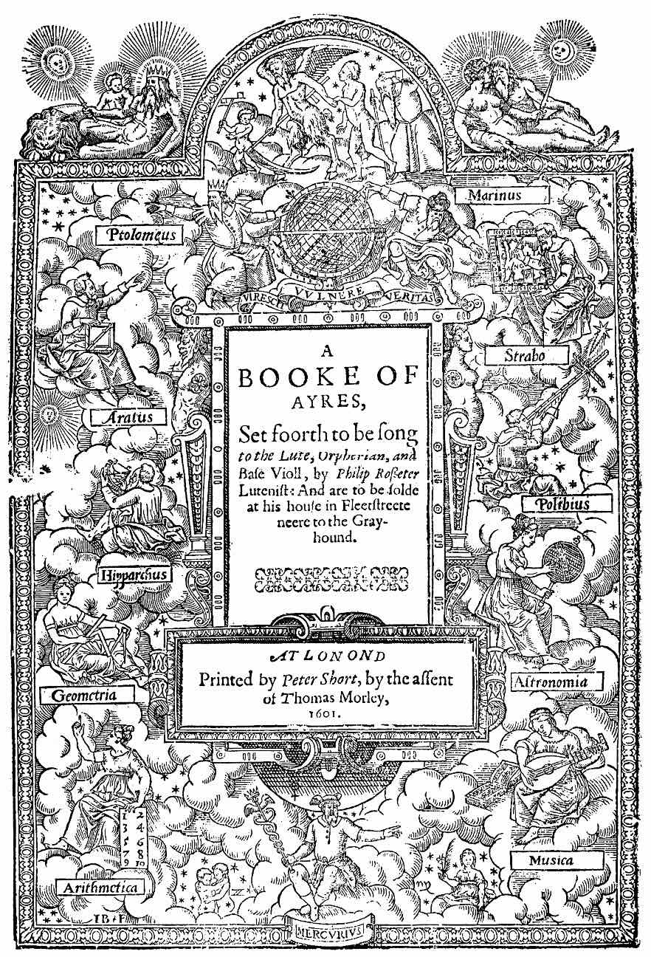

Title page of Rosseter’s *Ayres* 1601.

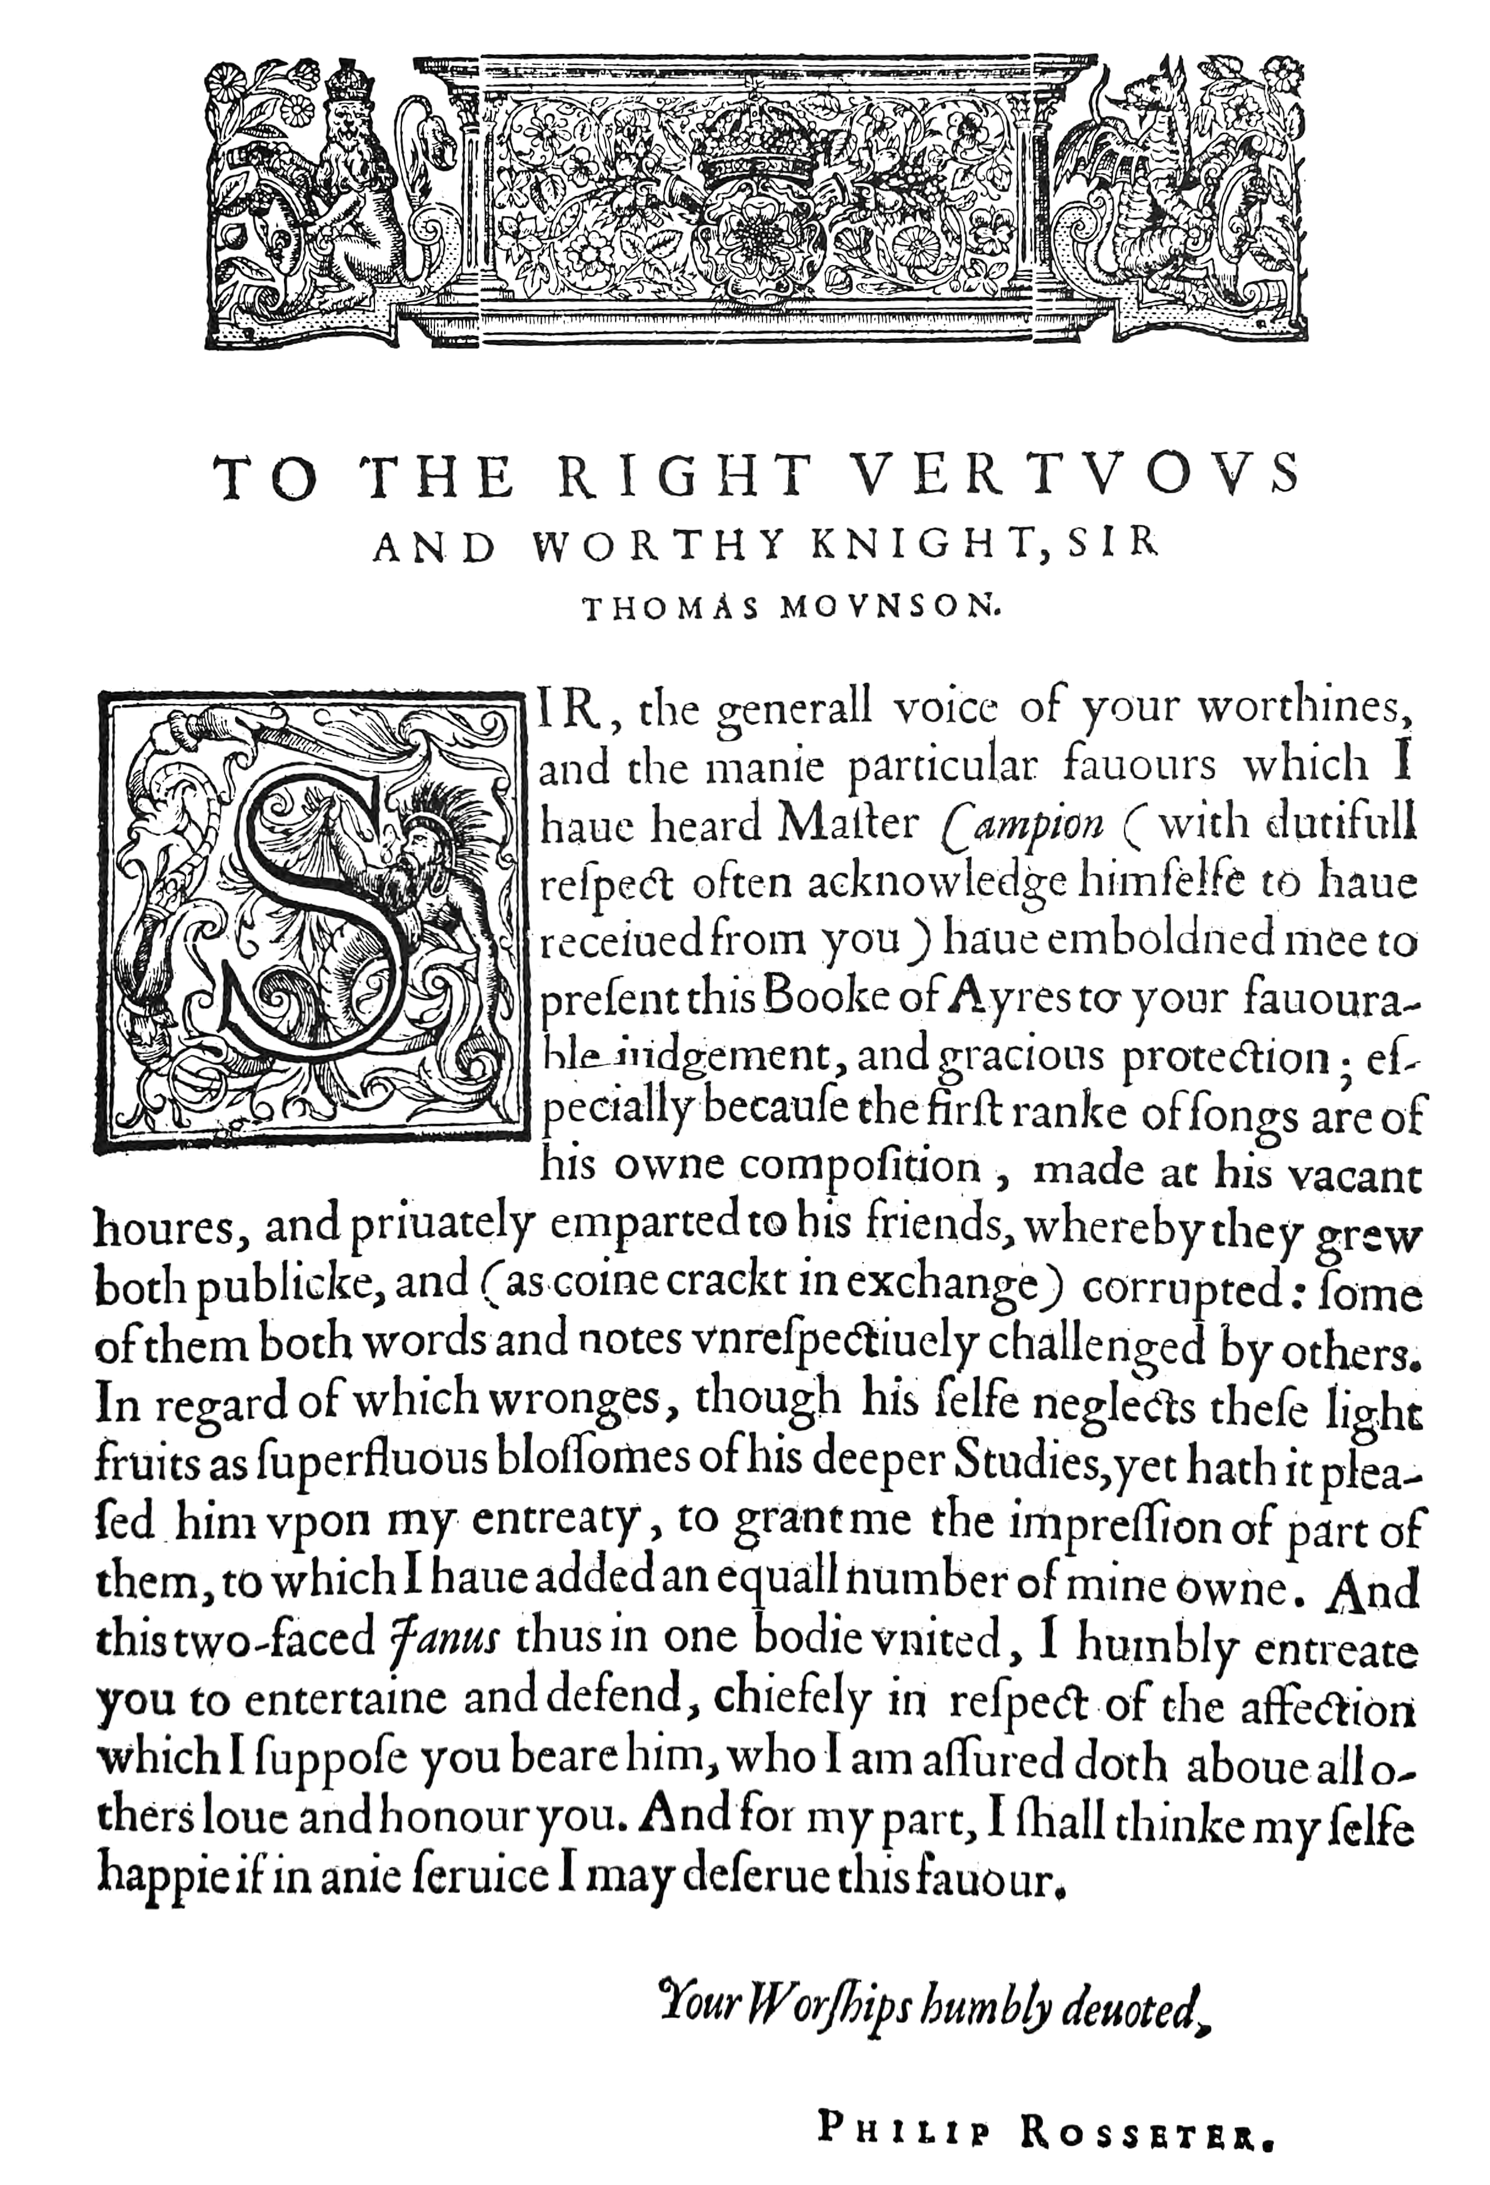

Dedication from Rosseter’s *Ayres* 1601.

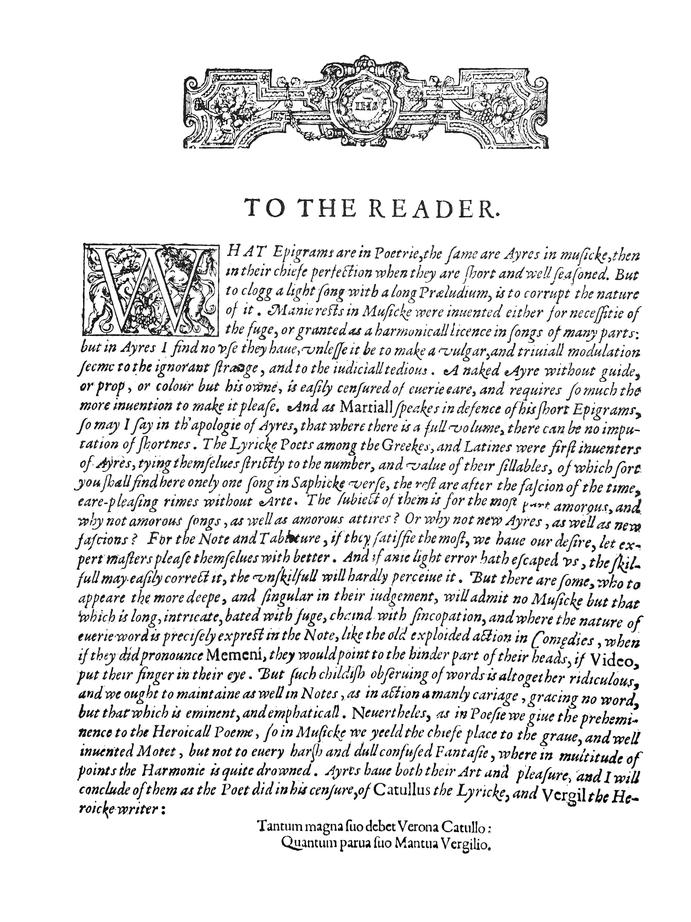

Address to the reader from Rosseter’s *Ayres* 1601.

1. See Diana Poulton *John Dowland* (London, Faber & Faber 1972 & 1982), pp. 245-247; Nigel Fortune ‘Philip Rosseter and his songs’ *The Lute Society Journal* vii (1965), pp. 7-14; John Jeffreys *The life and works of Philip Rosseter* (Aylesbury, Roberton Publications 1990) - reviewed by Christopher Morrongiello The Lute 31 (1991); Ian Harwood ‘Rosseter, Philip’ *Oxford Dictionary of National Biography* online.
2. Public Record Office, REQ/2/203/4, p. 14.
3. Christiaan Vlam and Thurston Dart ‘Rosseters in Holland’ *Galpin Society Journal* xi (1958), pp. 63-69.
4. In 1592 she married Robert Radcliffe (1569-1629), 5th Earl of Sussex from 1593.
5. William Barley *A new Booke of Tabliture* (London 1596). Modern edition, ed. W. W. Newcomb *Lute Music of Shakespeare’s Time. William Barley: A new Booke of Tabliture, 1596. Edited and transcribed for keyboard with the original tablature* (University Park & London, Pennsylvania University Press 1966).
6. Philip Rosseter *Lessons for Consort* (London, 1609). Surviving parts in London, Royal College of Music, B105 (cittern, lacking sig. C4, nos. 22-25); New York, New York Public Library, Drexel 5433.5 (flute); Oxford, Bodleian Library, Mus. 157 b.1 (lute, fragments of sigs. C2, D1 & D2, nos. 5-9). See also Ian Harwood ‘Rosseter’s Lessons for Consort of 1609’ *The Lute Society Journal* vii (1965), pp. 15-23.
7. Philip Rosseter *A Booke of Ayres* (London 1601). Copies in London, British Library, K.2.i.3; San Marino, California, Huntington Library, 13568 (lacking sigs. G2-M2, i.e. all the songs by Rosseter); and Cambridge, Mass., Harvard University, Houghton Library, 21332 (lacking quires A and G). Modern edition, ed. E. H. Fellowes *The English School of Lutenist Song Writers* first series, iv (London, Stainer and Bell 1922), pp. viii-ix (1923), and xiii (1924); vols viii-ix revised by Thurston Dart in new series *The English Lute-Songs* (London, Stainer and Bell 1966). Facsimile edition, David Greer (ed.) *English Lute Songs (1597-1632)* 36 (Menston, Scolar Press 1970, reprinted 1977). See also Peter Warlock *The English Ayre* (London, Oxford University Press 1926), pp. 106-110; Erik S. Ryding ‘Collaboration between Campion and Rosseter?’ *Journal of the Lute Society of America* xix (1986), pp. 13-28; and Robin Headlam Wells ‘Ars amatoria: Philip Rosseter and the Tudor court lyric’ *Music and Letters* 70 (1989), pp. 58-71.
8. Kenneth Sparr ‘Some unobserved information about John Dowland, Thomas Campion and Philip Rosseter’ *The Lute* xxvii (1987), pp. 35-37.
9. Andrew Ashbee *Records of English Court Music* (RECM) iv (Menston, Scolar Press 1986), pp. 9 & 76; RECM viii (Menston, Scolar Press 1995), p. 56; Andrew Ashbee and David Lasocki with Peter Holman and Fiona Kisby *A Biographical Dictionary of English Court Musicians 1485-1714* (Aldershot, Ashgate 1998), II, pp. 973-975; John M. Ward ‘The King’s Luters, 1593-1612: Philip Rosseter’ *Journal of the Lute Society of America* x (1977), p. 111.
10. RECM iv, pp. 109, 110 & 113.
11. W. P. Baildon *The Records of the Honourable Society of Lincoln’s Inn* The Black Books (1897-1902), II, pp. 155 & 156.
12. RECM IV, pp. 42, 91 & 234; RECM VIII, p. 72; E. K. Chambers *The Elizabethan Stage* (Oxford, Clarendon Press 1923), p. 343.
13. David Greer ‘Rosseter, Philip’ *Grove Music Online*.
14. A. H. Bullen (ed.) *The Complete English Works of Thomas Campion* (London, Sidgwick and Jackson 1903), p. xxix; Percival Vivian *Campion’s Works* (Oxford, Clarendon Press 1929, reprinted 1966).
15. His will (PCC Lpro, PROB 10/401, register copy PROB 11/141) was proved by his sons Dudley and Hugh.
16. In *The Renaissance Guitar* (1974) pp. 104-105, Frederick Noad printed a guitar transcription entitled ‘Mrs Taylor’s Galliard by Philip Rosseter’ from GB-Cu Dd.5.78.3, ff. 8r & 8v, where the title is ‘Mrs fr. Taylers Galliard Ro Kenn’ and the composers name is expanded on f. 7v to ‘Ro[bert] Kennerley’. Noad presumably misread Ro Kenn as Rosseter.
17. D. Poulton & B. Lam, *The Collected Lute Music of John Dowland* (London: Faber 1974, 1978 and 1981), no. 71.
18. Facsimile edition (London, Scolar Press 1977). Twenty one songs by Thomas Campion followed by twenty one by Philip Rosseter. A convincing case was made in Ryding 1986, *op. cit.* that Rosseter composed the lute accompaniments to the song texts by Campion, as well as his own. See fn 7.
19. See fn 6.
20. Thomas Morley *The First Booke of Ballets to five voices* (1595).
21. All lute settings edited for *Lute News* 61 (April 2002).
22. Lyle Nordstrom *The Bandora its Music and Sources* (Warren, Michigan 1992).
23. Warwick Edwards *Music for Mixed Consort*, *Musica Britannica* XL (London, Stainer and Bell 1977).
24. Rainer aus dem Spring (ed.) *Anthony Holborne: Music for Lute and Bandora* vols. I & II (Albury, The Lute Society, 2001).
25. Sydney Beck *The First Book of Consort Lessons collected by Thomas Morley, 1599 & 1611* (New York Public Library 1959).
26. All lute settings edited in *Lutezine* to *Lute News* 118 (July 2016).
27. All lute settings edited in *Lute News* 114 (July 2015).
28. Modern edition: J.A. Fuller Maitland and W. Barclay Squire *The Fitzwilliam Virginal Book* (London 1899, reprinted New York, Dover Publications, 1963), no. 283, pp. 250-251; John Baxendale and Francis Knights (eds.) *The Fitzwilliam Virginal Book* (Lyrebird Music 2020), no. 283, pp. 339-342 and facsimile in Plate 06 on p. 343.